**Task 01**

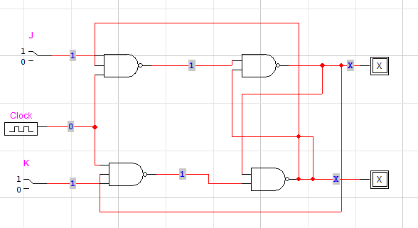

**Task 02**

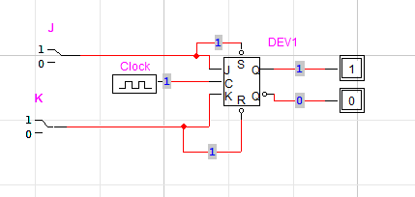

**Task 03**

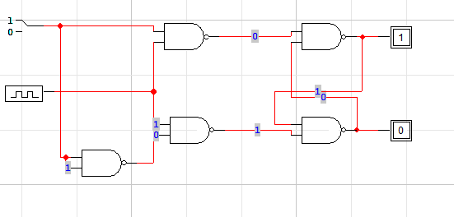

|  |  |  |  |  |
| --- | --- | --- | --- | --- |
| **D** | **Clock** | **Q** | **Q’** | **State** |
| 0 | 0 | Q | Q’ | No Change |
| 1 | 0 | Q | Q’ | No Change |
| 0 | 1 | 0 | 1 | Reset |
| 1 | 1 | 1 | 0 | Set |